**MyMoviePlan Write up**

By: Vijay Moirangthem

# Github link:

<https://github.com/VijayMoirangthem/MyMoviePlan.git>

**Project's Objective**

Create a dynamic and responsive web application for booking movie tickets online for different genres and languages.

**Background of the problem statement**

NMS Cinemas is a chain of single screen theatres that screen movie shows of different genres and languages at very genuine prices. It was established in 2004 in Pune, India. Recently, the business analysts noticed a decline in sales since 2010. They found out that the online booking of movie tickets from apps, such as BookMyShow and Paytm were gaining more profit by eliminating middlemen from the equation.

As a result, the team decided to develop an online movie ticket booking web application with a rich and user-friendly interface.

**Sprint Details**

**Sprint 1:**

* Analysis
* Entities
* App & Assests
* Model & Controller

**Sprint 2:**

* Registration & Login Check
* User & Admin Portal Check
* Bookings & Confirmation Check
* Testing

**Sprint 3:**

* Improvements in App Navigation
* Documentation

**Features of the Application:**

* Registration
* Login
* Payment gateway
* Searching
* Filtering
* Sorting
* Dynamic data
* Responsive and compatible with different devices

**Technologies Used:**

* Database management: MySQL and Oracle
* Backend logic: Java programming, NodeJS
* Frontend development: JSP, Angular, Bootstrap, HTML/CSS, and Javascript
* Automation and testing technologies: Selenium, Jasmine, and TestNG
* DevOps and production technologies: Git, GitHub, Jenkins, Docker, Kubernetes, and AWS

**Admin Portal:**

It deals with all the backend data generation and product information. The admin user can manage the following functions:

* Add or remove different genres to or from the application to build a rich product line
* Edit movie details like name, ticket price, language, description, and show timings to keep it aligned to the current prices
* Enable or disable the movie shows from the application

**User Portal:**

It deals with the user activities. The end-user can do:

* Sign-in to the application to maintain a record of activities
* Search for movie tickets based on the search keyword
* Apply filters and sort results based on different genres
* Add all the selected movie tickets to a cart and customize the purchase at the end
* Experience a seamless payment process
* Receive a booking summary page once the payment is complete

**How to run the program:**

* Clone project
* Import the file from Github to your local repository

**#For BackEnd**

* Load Project to Eclipse/InteliJ
* Change Configuration Settings
* Run the Project

**#For FrontEnd**

* Load the Project to VsCode
* npm install
* ng serve

**Implementations Steps**

# Image 1.

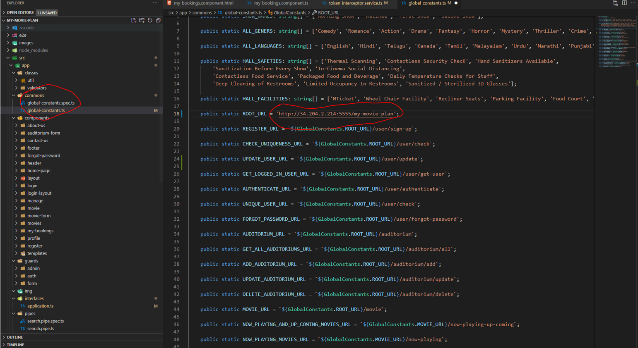

# Image 2.

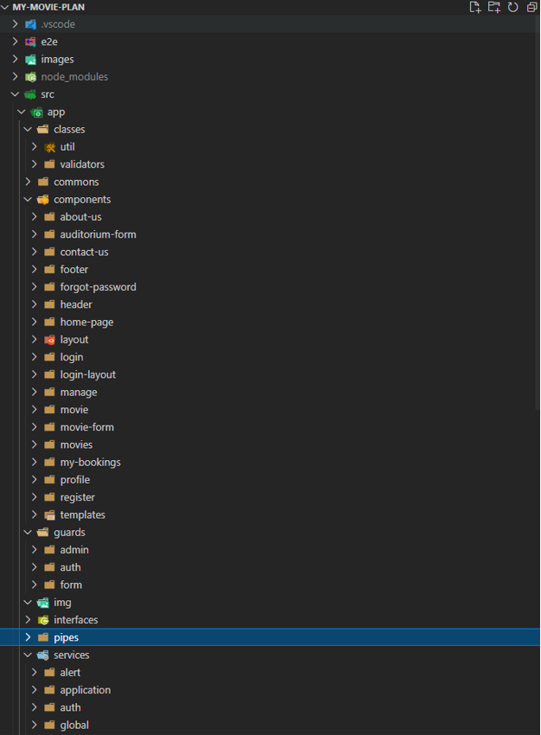

# Image 3.

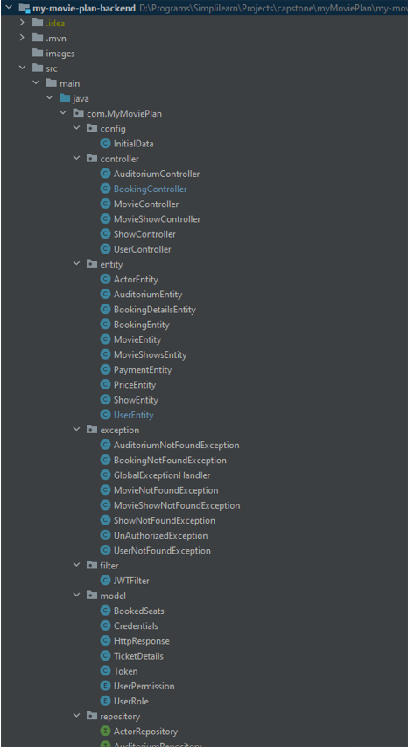

# Image 4

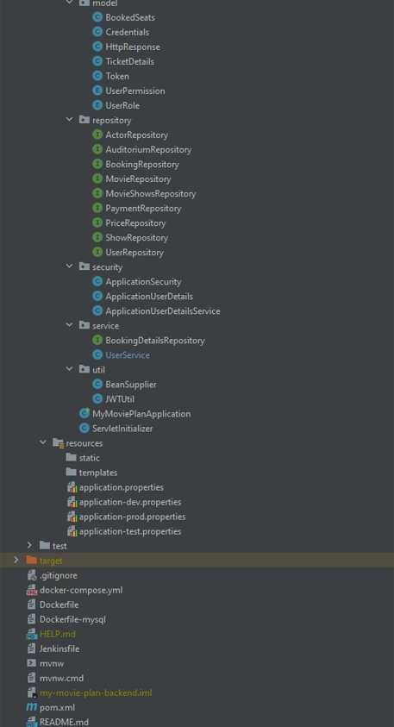

# Image 5.

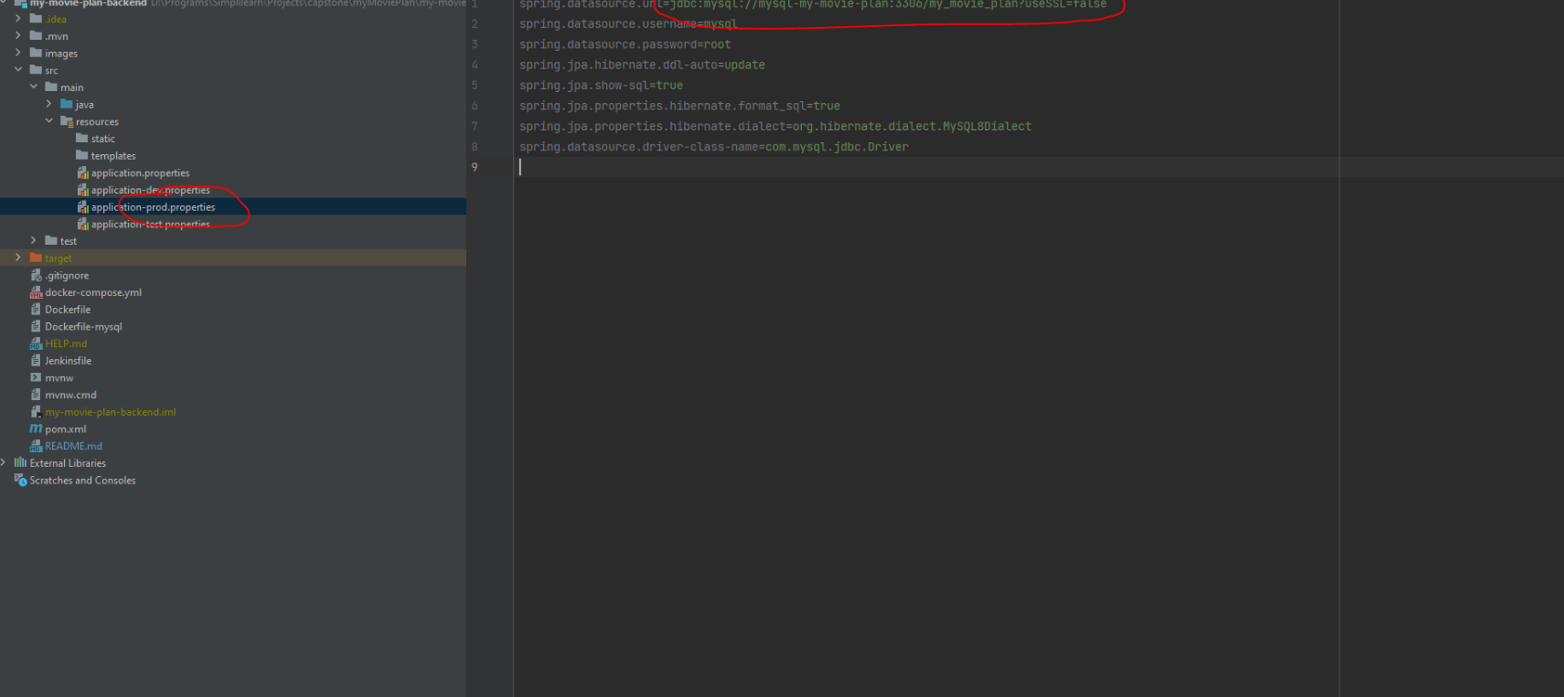

# AWS management console:

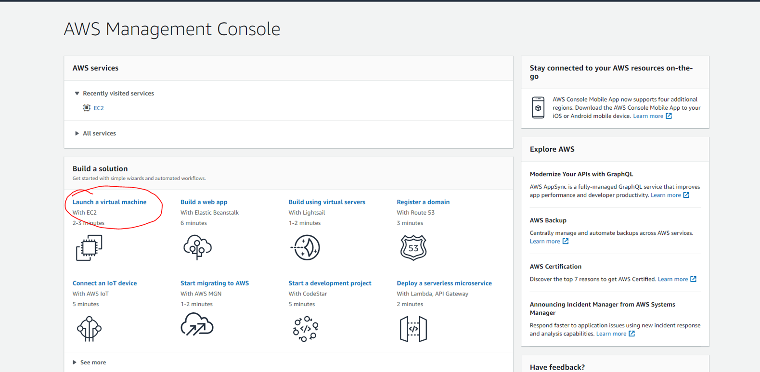

# Img:

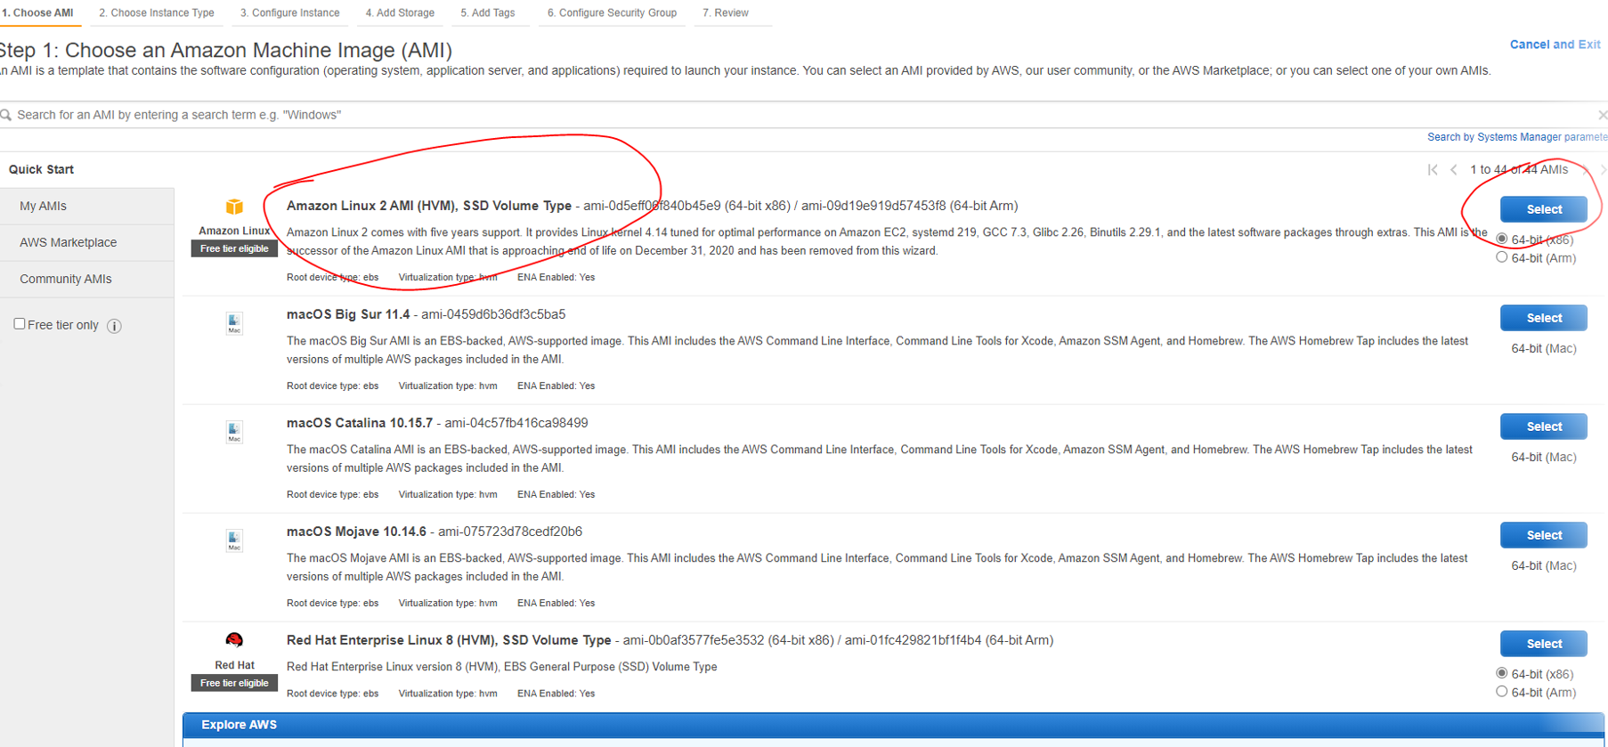

# Img:

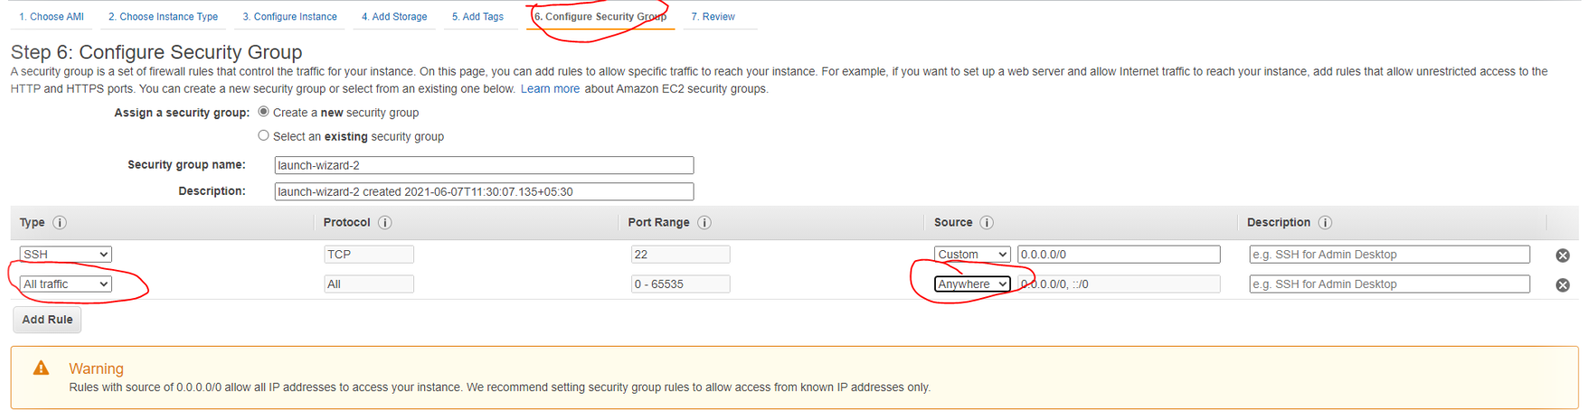

# Img:

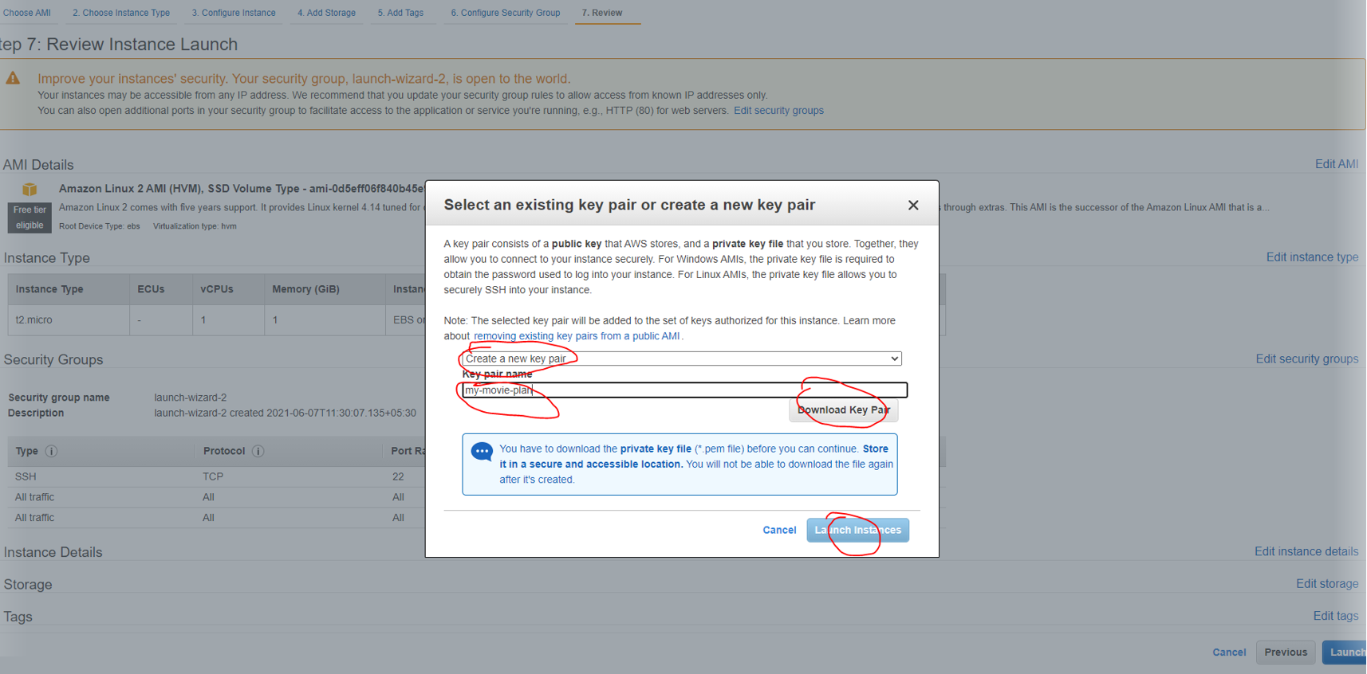

# Img:

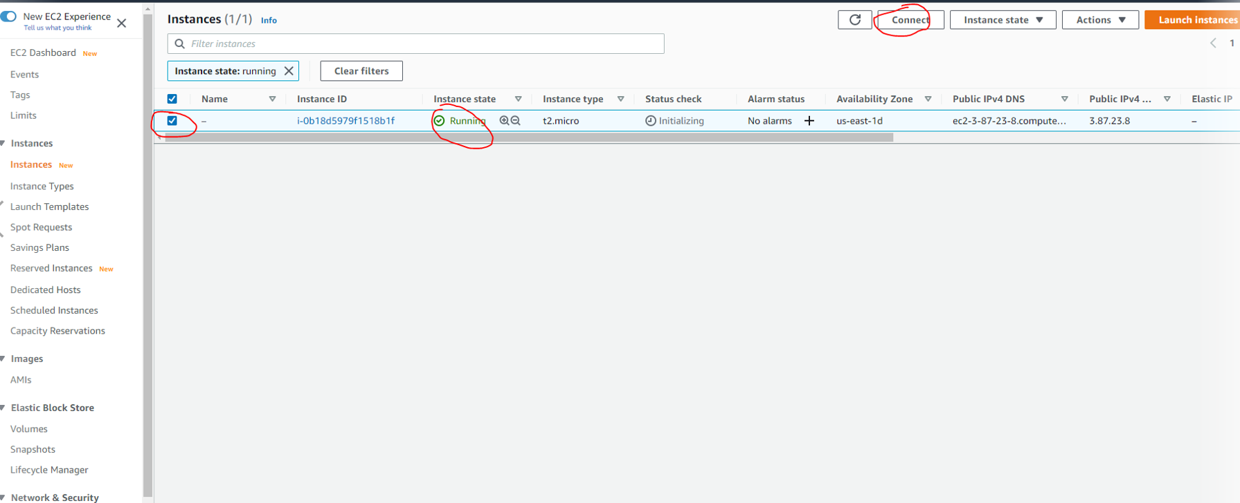

# Img:

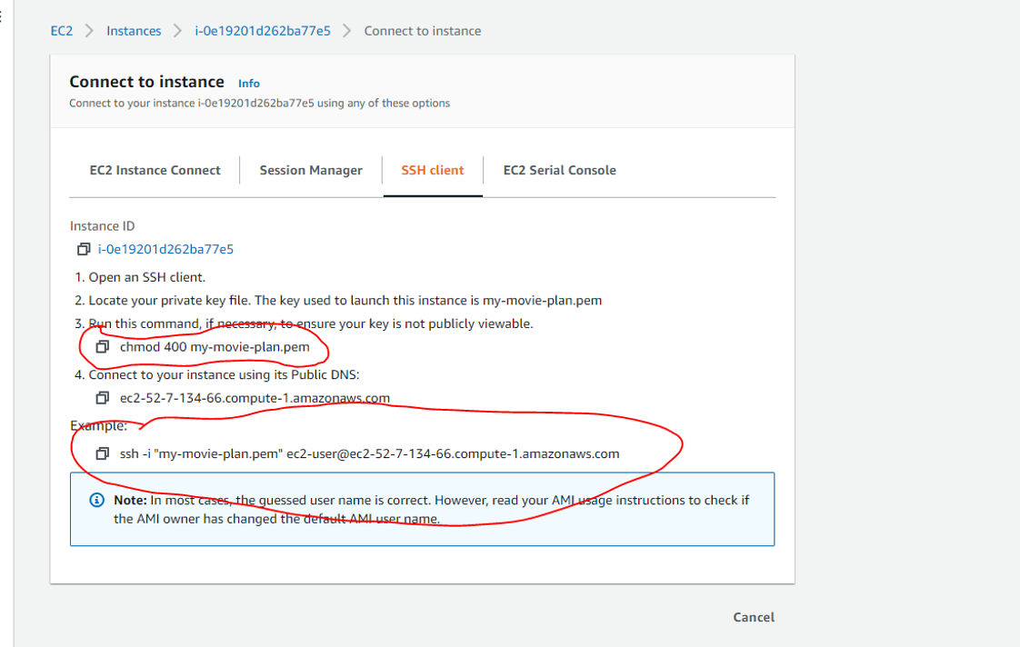

# Command prompt:

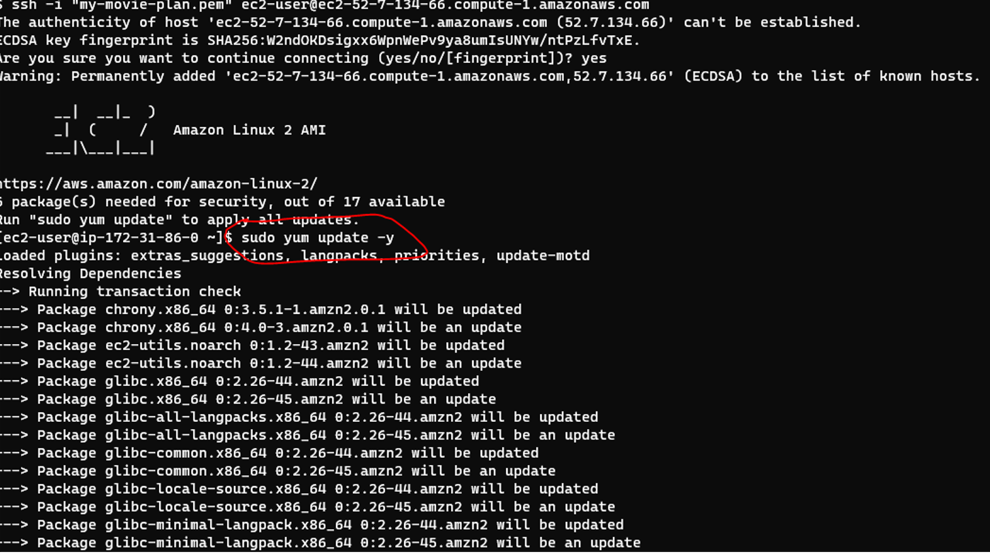

# Jenkins:

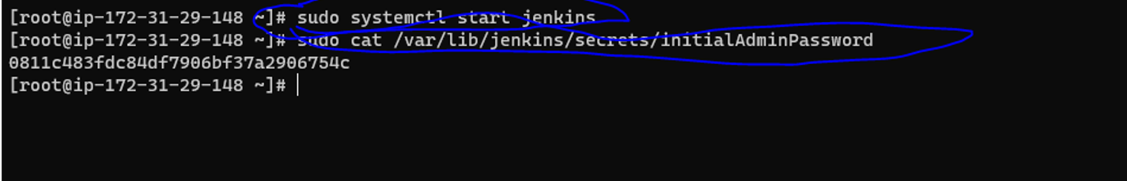

# Unlock Jenkins:

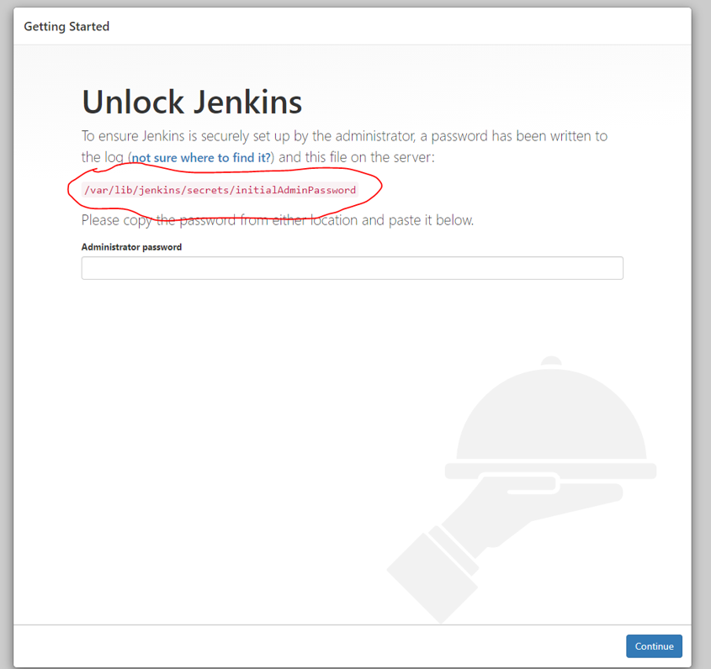

# Customize:

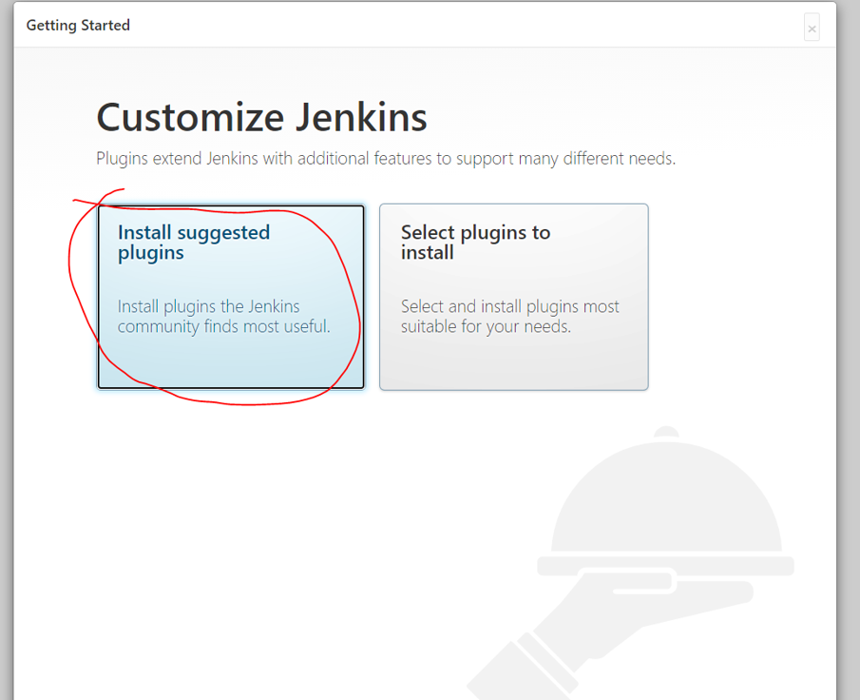

# Create:

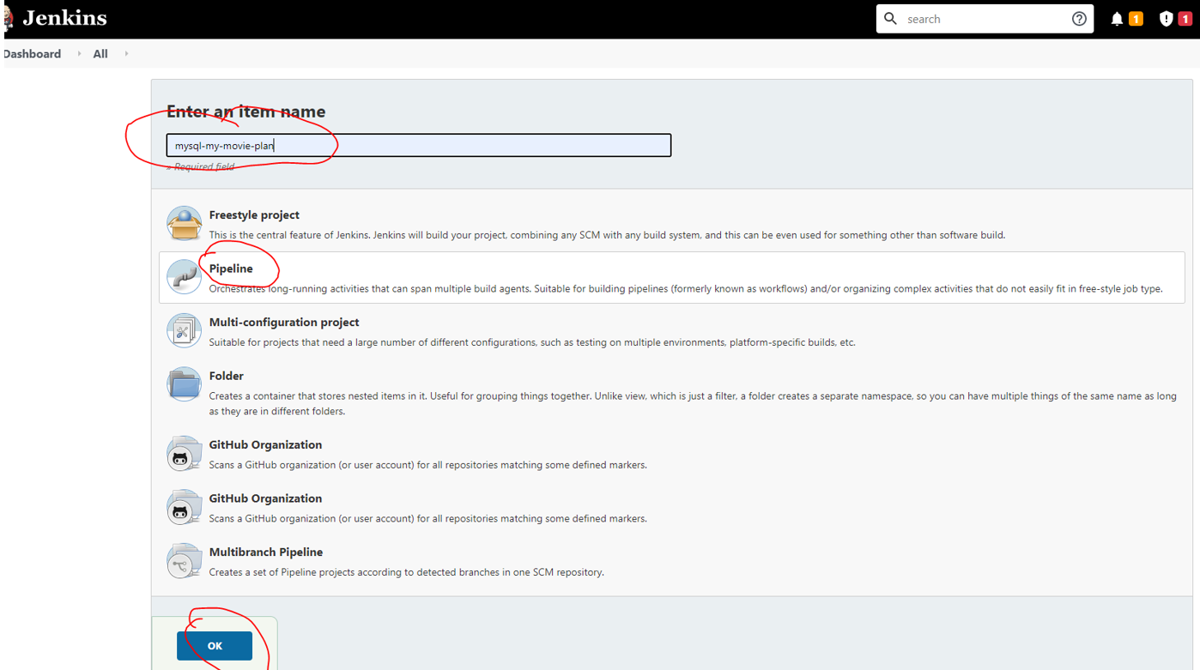

# Docker:

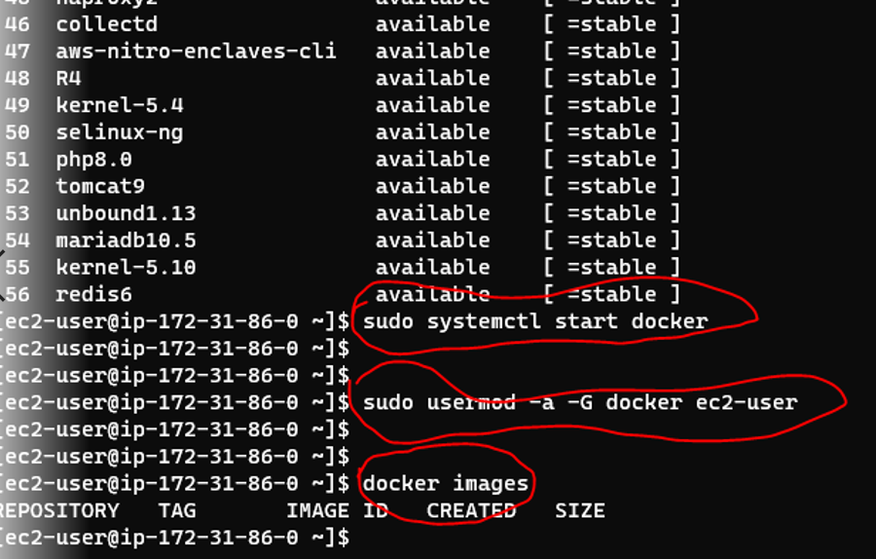

# Docker 2:

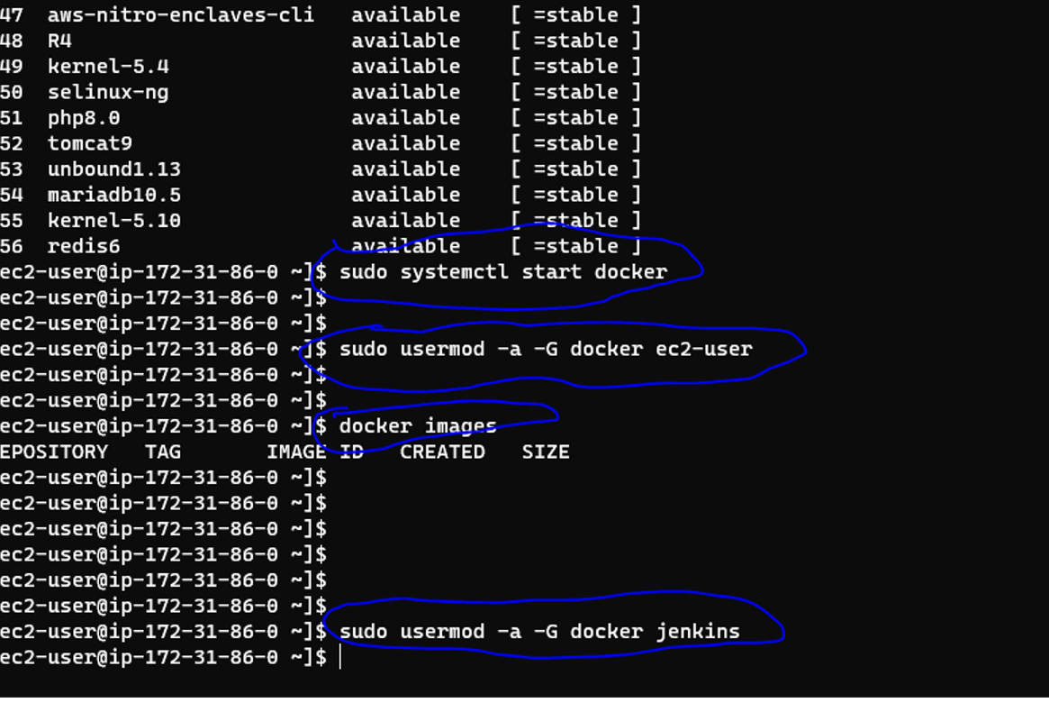

# Jenkins details:

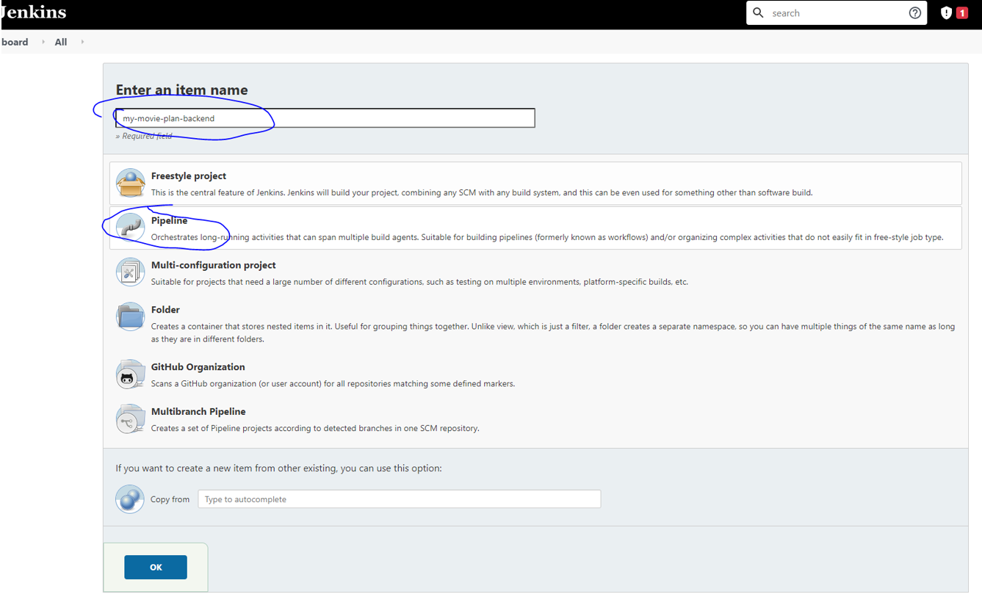

# Backend:

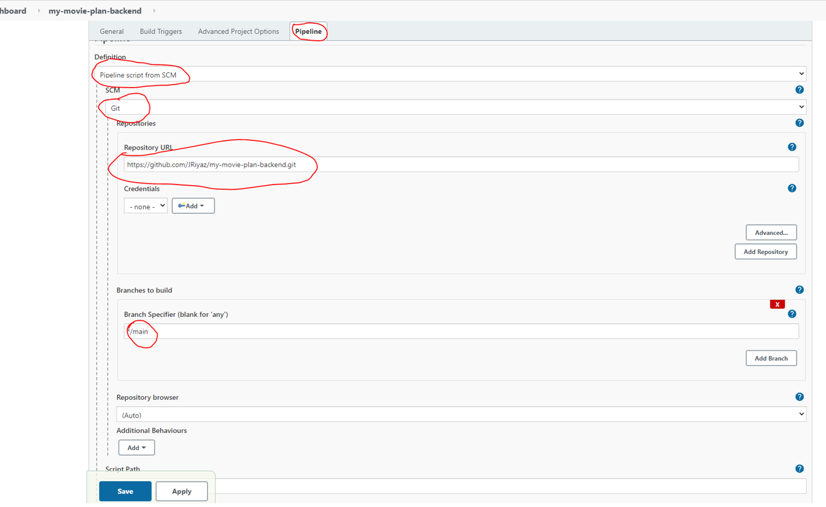

# Global Tool Configuration:

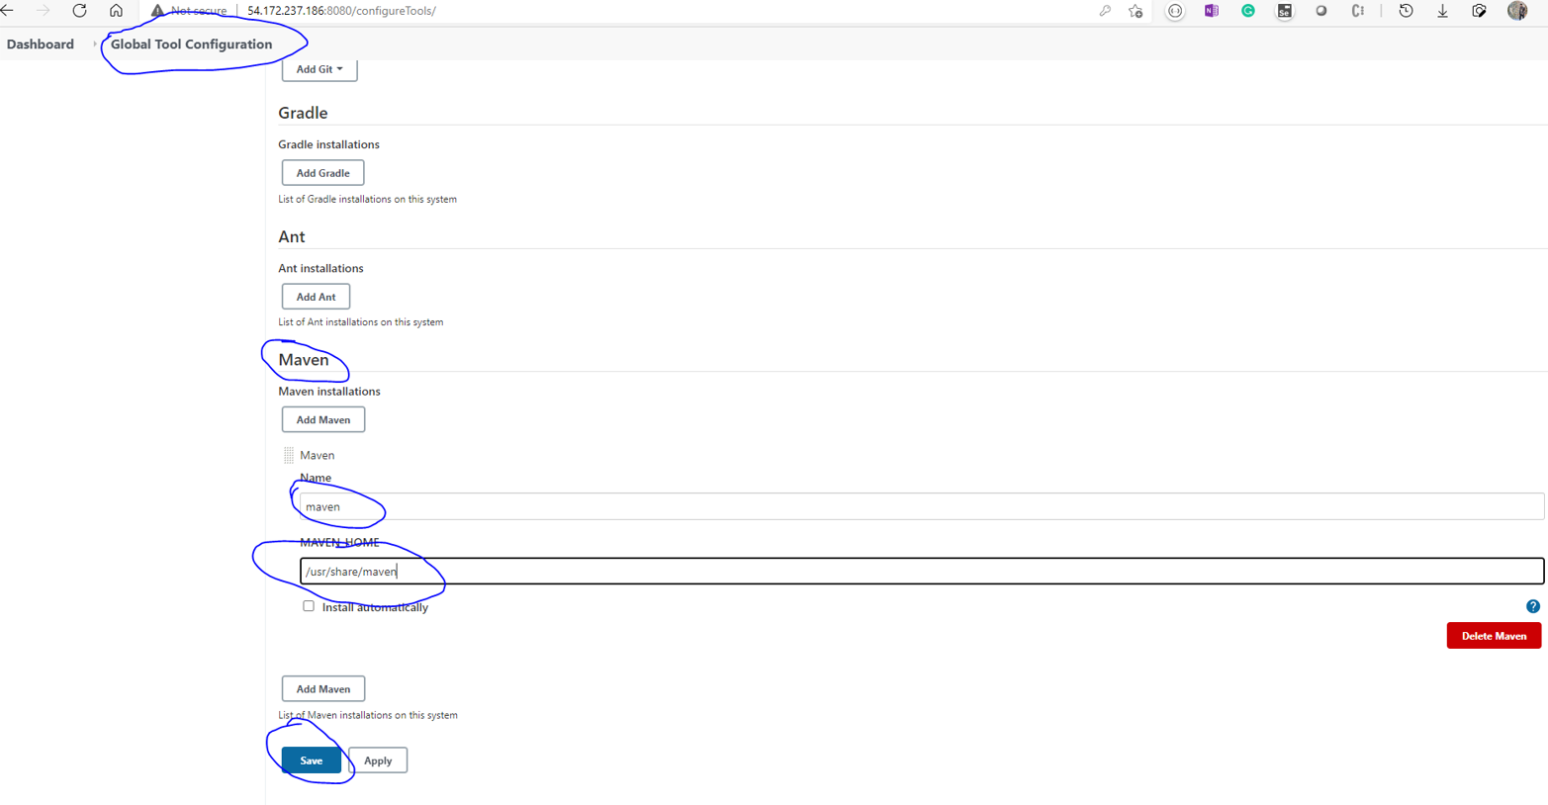

# Pipeline:

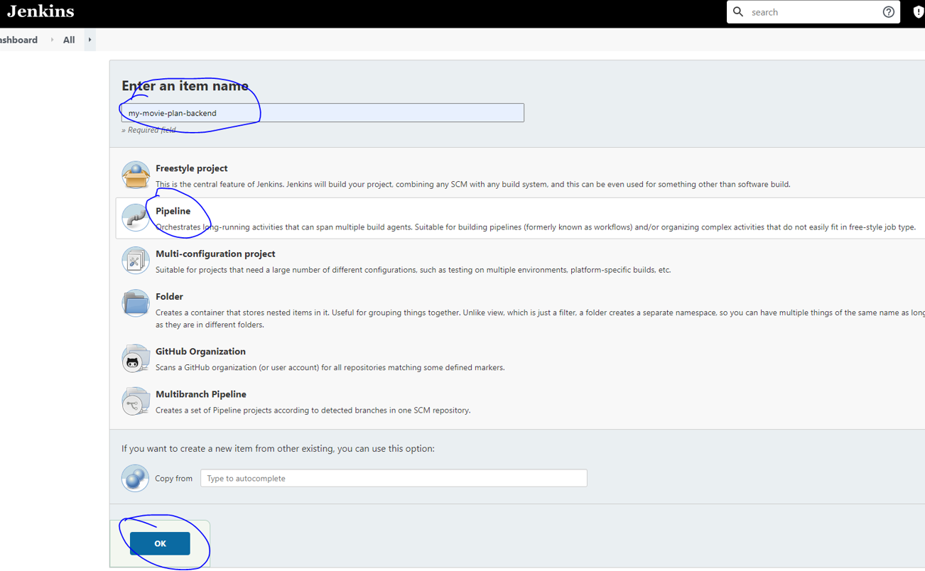

# Triggers:

